Software Requirements Specification
for
Market Stock Price System
Version 1.0 approved
Başak KARADENİZ
STAND-ALONE COMPANY 12.12.2021
Table of Contents
Table of Contents ii
Revision History ii
1. Introduction 1
1.1 Purpose 1
1.2 Document Conventions 1
1.3 Intended Audience and Reading Suggestions 1
1.4 Product Scope 1
1.5 References 1
2. Overall Description 2
2.1 Product Perspective 2
2.2 Product Functions 2
2.3 User Classes and Characteristics 2
2.4 Operating Environment 2
2.5 Design and Implementation Constraints 2
2.6 User Documentation 2
2.7 Assumptions and Dependencies 3
3. External Interface Requirements 3
3.1 User Interfaces 3
3.2 Hardware Interfaces 3
3.3 Software Interfaces 3
3.4 Communications Interfaces 3
4. System Features 4
4.1 System Feature 1 4
4.2 System Feature 2 (and so on) 4
5. Other Nonfunctional Requirements 4
5.1 Performance Requirements 4
5.2 Safety Requirements 5
5.3 Security Requirements 5
5.4 Software Quality Attributes 5
5.5 Business Rules 5
6. Other Requirements 5
Appendix A: Glossary 5
Appendix B: Analysis Models 5
Appendix C: To Be Determined List 6

Revision History
(No revision included)
Name | Date | Reason For Changes | Version

Introduction

Purpose
The created SRS diagram covers all parts of the system that I created and in this direction it is aimed to provide a product control with high flexibility and easy to use and control.

Document Conventions
English keyboard is a compatible and English-language system for the moment, although it is planned to create versions of the created system with various languages in the coming period. The reason for choosing this language is that it is the most common language used worldwide, and on the other hand, if the language is not known, it is aimed that the desired information can be easily accessed even over the Internet.

Intended Audience and Reading Suggestions
Our target buyers are planned to be mostly large companies with more than 50 employees or wholesale sellers, as it aims to reduce confusion to a minimum in the created system, and it technically does not support its use with less than 4 users, except for a super user. Depending on this situation, there are sections such as sub-user information, areas where they are located and assigned, company product fees, number of products entering and exiting, and sales statistics in our system, and various groups such as user 1, user 2 have been created for each of these sections so that all the desired data can be accessed regularly.
In the continuation of the SRS template, information will be obtained about the entire functioning of the system, but in order to have a visual overview and better understand the values that need to be given, it will be more efficient for the reader to study the diagrams at the end of the template and read them from beginning to end after they are examined. Even the reader can take a look to these diagrams while reading the template, because certain parts of what is written will be quoted from these diagrams.

Product Scope
There are various regulation and control systems used by companies in many parts of the world, but according to my research’s, these systems are usually created for the control or regulation of one thing, and each company uses multiple systems for such requirements. This may cause confusion in my opinion, but it is intended to eliminate such confusion in our system. In addition, aside from the confusion and time-consuming nature of various regulatory systems used by other companies, in the system we have created, such features have been collected in one place and tried to minimize the time it takes and it has been aimed that the company has more time to develop itself.

References

IEEE. IEEE Std 830-1998 IEEE Recommended Practice for Software Requirements Specifications.

Overall Description

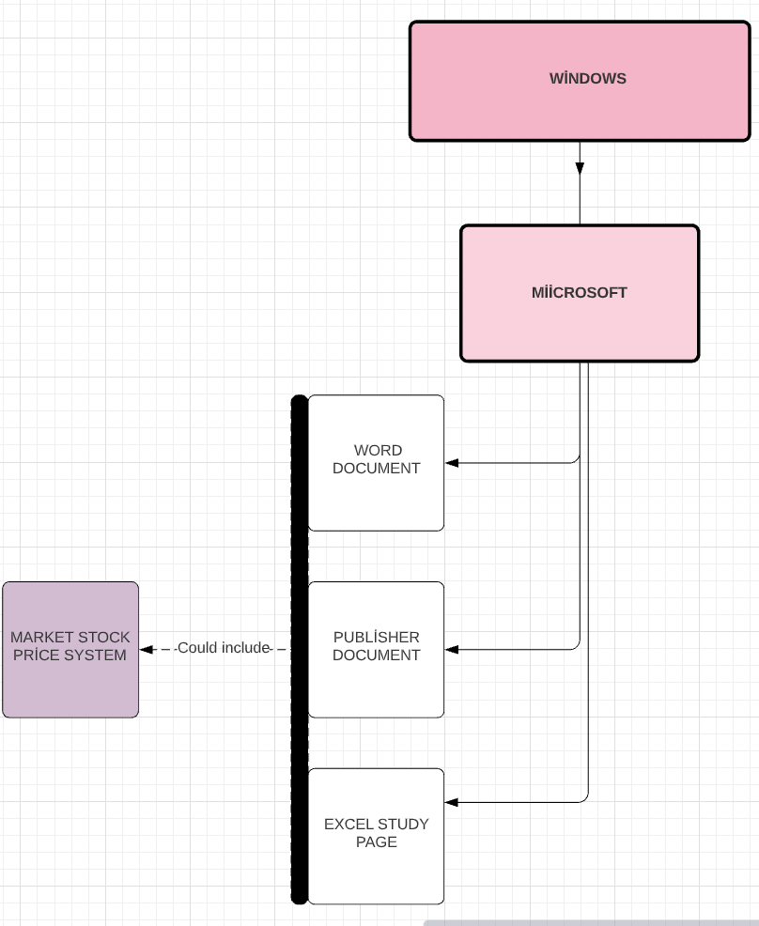
Product Perspective
Our system is based on windows and is not yet adapted for different bases, such as IOS, but all the filing methods that come with Office 365 with Windows can be transferred to the created system, because, as mentioned earlier, one of the most important goals of our system is its flexibility. Another detail that we want to give is, for example, if we consider a Microsoft excel worksheet, each created title and their sub-values can be easily defined by our system when they are specified when they want to be inserted into our system and can be thrown into the desired sub-title. In addition, the system we have created is executed via SQL server and can be easily used by downloading it to the main interface of the phone or computer, rather than via safari, if desired.

Product Functions
There are various arrangements such as the buyer information of the products received in accordance with the created system, the unique IDs of each product associated with the product, the user information inside the subunits except for the super-user, and even which user does what activity when (information that can only be viewed on the super-user side). In addition, another important use is that although there are different users for each unit, if information is requested from other units, the super-user is activated and the super-user's access approval is requested, as it should be in each function.

User Classes and Characteristics
Although our system tries to focus on reaching all kinds of people and having the least effort in terms of usability, certain groups of people may be needed in classes such as product purchases-sales or sales statistics because at some point, although our system has help, certain features play a role in entering the desired data.

- In the first general example, users may be required to have a university degree, because although a certain ability is not needed, the skills acquired at the university may be needed to understand the product input output and the data seen when a report is requested by a super-user under a company can be poured into the report.
- In the second example, if we can speak generally on behalf of user 1,2 and 3, we can say that the fact that there is a system for using people who have graduated from an engineering branch, an economics branch, or a mathematics branch is an important point both for the usability of the system and for the super-user to be able to execute the system with less effort.
- Another feature that can be mentioned is that the codes at the base of our system and the way they work can be found and change from everyone. In this way, for example, if the company that purchased our system has a computer engineering graduate or a unit authorized to write and develop code under it, this unit can shape the system with the permission of the super-user according to its own benefits in the system without the need for us, market stock price system developers.

Operating Environment
Hardware Environments: Personal computers, company owned computers and IPad’s.
Software Requirements: C++,JavaScript, Firebase-Firestorm and SQL server

Design and Implementation Constraints
* The system can be run under windows and under android.
* E-commerce code must be applied to the system.
* Firebase Cloud can be used as a Fire store database and located on the local host.
* The codes in the system should be designed to be reusable.
* The buyer after the sale of the system must apply the security requirements specified in chapter 5 for the development of a system-based system.

User Documentation
If our system is purchased, we will have a 10-minute demonstration video that comes with the system, but only buyers have access to, and all the requirements of our system are focused on. As mentioned in the later articles, our system has been given ease of use and flexibility in terms of using text boxes, and although this contradicts the flexibility of the system we have created, we have also created a guide that provides detailed information about text boxes to neutralize this situation. At the same time, we provide comprehensive and detailed information about how to reach the interface of the system in the created guide and what values can be changed in order to ensure the flexibility of our system. On the other hand, although there is a disconnect between the seller and us after the purchase of the system, in any case, a complaint can be created and sent by mail or by clicking on the live support box on our site to receive 24/7 support.

Assumptions and Dependencies

External Interface Requirements

User Interfaces
The purpose of the design of all user interfaces is easy accessibility to everything and, as already mentioned, a flexible structure. Along with this situation, the best performance is aimed for the user on the pages in the system, and for this purpose, the graphics in the system are reduced to the simplest.
When entering the system, there must be an interface on which the user must first log in. This interface is redirected to a second page according to the department type of the person who entered according to the entered password and the accuracy of the PIN code, and if the super-user is logged in, each section in the system in checkboxes is at hand. Along with this situation, the super-user also has an extra box that collects all input-output transactions and data on which computer they are made by, aside from the other users' page. In this way, the reliability of those using the system can be increased and the company can be monitored no matter how large the company is, whether the work done in accordance with the requirements of the super-user is focused on.
Another user interface that should be mentioned is the interfaces used by other users, because they are all designed according to their own departments, and they can get information on the boxes in not their hands as long as the super-user gives permission. In addition to the interfaces mentioned, there are various filtering/sorting functions and modifying/editing functions inside the created boxes. These functions are not possible to be performed with super-user permission, but super-user is already will be aware of such changes.
Another important feature of the interfaces used is the warning interfaces sent to put the user back on the right path in case of misdirection, because in this way, maximum usability of the system is ensured. For example, if the 2nd user enters the wrong currency, while trying to find the sales value of a product, in short, if he enters a different entry, he will receive a warning with the data he wanted to receive before, and our system also provides the following values. The user can request in front of him.

Hardware Interfaces
The reliability and ease of use of SQL server are higher in direct proportion to the flexibility of the inventory system that we have created, but the C++ coding language was also needed to edit various adjustments. Examples of these needs are profit-loss calculation, learning how much product stock is left, and the conveniences provided when new arrangements are made, etc...

Software Interfaces
The backend of our systems is connected to the Firebase and Firestorm cloud database. Thanks to these applications, as I mentioned in the above articles, each step taken by each user using the system is transferred to the database along with the hours and dates. From the moment users log in to the system, data storage is started and transferred to memory with a certain capacity, which is renewed every year. Along with this situation, every time the user receives new entries or receives an alert, or makes a change to the values in the system, they are used by Firebase and Firestorm as above it is transferred to memory for a period of one year.

Communications Interfaces
Our system will rely on HTTP/HTTPS protocols for communication with the server back and forth.

System Features

Independency

Description and Priority
One of the high priority values of the system we have created is that a company that owns our system will stop communicating with the seller, that is, us, after the purchase of the system, and although the main purpose of the system we have created is to make it easy to be controlled by one person, there may be difficulties when all controls remain for one person so that when the company needs, our system will have some services about these situations. . (From 1(low) to 9 (high) scale of priority this task has a rate of 9.

Stimulus/Response Sequences
For those situations, although all the controls remain with the main user, when contacting us in case of various blockages or inability to find an answer, it is clear that our system is general in a certain process, it may take 1-2 weeks for us to strengthen the system on behalf of new and previously unthinkable features, that is, to make a new update according to the difficulty of the desired feature in the system, and we may have fulfilled the wishes of our buyer. This update process also has 3 steps. Firstly, it is necessary to determine the problem, secondly, it is unanimously accepted that the system is compatible with its characteristics and provides a general value for each user, and finally, the third step also includes the application.

Functional Requirements
REQ-1: A support button on the system's website or on its main interface.

Log in Page

Description and Priority
The purpose of this feature is to allow users to log in to a specific category of the system and have rights over the system according to the departments they are in. Our system also aims to improve the reliability of the system by using encryption and two-factor authentication methods for intruders. . (From 1(low) to 9 (high) scale of priority this task has a rate of 10.)

Stimulus/Response Sequences
At the login stage of the system, the system requests a user ID and password from the user, when these data are entered, the remember user key can also be pressed before the login button is pressed, and thanks to this feature, the same user does not need to remember his ID if he logs into the system from the same device. Secondly, if the entered informations are correct, a second firewall PIN code is requested, and the desired PIN code is the second stage of our security system. The PIN code will drop to the user's phone and this PIN code is renewed every time you log in to the system so that you get a high level of security.
In addition, since there is a two-factor verification requirement, the super-user must also have this user's phone number in case of creating a new sub-user.

Functional Requirements
REQ-1: Database system shall be implemented accordingly.

REQ-2: User id and password boxes.

REQ-3: Users phone number for PIN num. control.

Registration Page

Description and Priority
The registration section of the system can only be used by the super-user, but sub-departments can be authorized if desired. Along with this situation, in order for the super-user to create a new employee, the user must have every information from the username to the home address and even the password that he/she will have. (From 1(low) to 9 (high) scale of priority this task has a rate of 7.)

Stimulus/Response Sequences
If a super-user wants to add a new employee, when they enter into their own interface in the main menu boxes, there is also a located box which name is "registration" and if the super-user fills the registration table with the informations of the new employee, the super-user can click "register new user" button at the end and he/she will be successful to create a new user.

Functional Requirements
REQ-1: Extra box in the super-users main interface

REQ-2: New user’s informations

REQ-3: Database system shall be implemented accordingly.

Searching and Filtering Products

Description and Priority
Throughout the created system, there are lists that are visited with boxes, and thanks to these lists, it is aimed that each desired information can be accessed more easily, so the filtering and searching feature plays a larger role in our system than in other systems. At the same time, attention was paid to the density of search buttons during the design process of the system and they can be found in almost every interface. (From 1(low) to 9 (high) scale of priority this task has a rate of 8.)

Stimulus/Response Sequences

Depending on this situation, certain data arrangements have been made and there is a search button on each page, except for the login page, and a filtering button on each page that has been listed. At the same time, the search button used also helps the user to get an answer when a question is asked.

Functional Requirements
REQ-1: Lots of boxes

REQ-2: A search engine that can detect the desired data while it is being typed into the search box and at the same time remember past searches

Other Nonfunctional Requirements

Performance Requirements

The system must be based on the computer subsystem.

The system should contain a real-time database as a database so that it can perform all its operations faster.

The user must be connected to the internet in order to use the system.

The products entered into the system must be updated simultaneously with the system.

The system must be operational 24/7.

Safety Requirements

Double-factor verification should be used when trying to provide user input

The user ID can be remembered using the remember me button when logging in as a member

The rights of users and all values of the company are confidential, and user information is not accessible to them, except for the super-user

Security Requirements

When there is no transaction within the system for a certain period of time, users' accounts will be logged out of the login process

At the member login stage, each unit that the user enters while typing the password or entering the PIN code, entering the numbers, will appear as an asterisk, and so there will be no attempt by anyone around to see the password and infiltrate the system as if it were their own account

In cases such as device changes that system users (including super-user) will experience, an additional email address verification will also be requested

The system's back-end servers will only be accessible to admins with permissions, such as a super-user.

The databases of the system will be encrypted.

Software Quality Attributes

Business Rules
<List any operating principles about the product, such as which individuals or roles can perform which functions under specific circumstances. These are not functional requirements in themselves, but they may imply certain functional requirements to enforce the rules.>

Other Requirements
Appendix A: Glossary
- Super-user: By the definition of our system, a super-user is a person who manages a company and buyers of our system, which means that a company with a lot of employees has all the controls of the market stock price system alone, but also has the ability to share the controls he has.
- User-1: User 1 is the people in the unit who can access the entries of the products sold in the company using the system, and these people can also check the stocks of the products at hand and get support from the super-user when the necessary changes are requested.
- User-2: User 2, unlike user 1, controls the outputs of the products, not the product inputs, but they also have the right to view the stock system, such as user 1 and, of course, super-user.
- User -3: User 3's permissions are slightly different from other users and they are not considered to be completely inside the company. They can only log in to the system and access the statistics of product sales and purchases, acting only on the instructions of the super-user. As a requirement of this situation, it is also more appropriate to say they are more part-time employees because they are engaged in a very short time of the company's functioning process.

Appendix B: Analysis Models
- Sequence Diagram 1
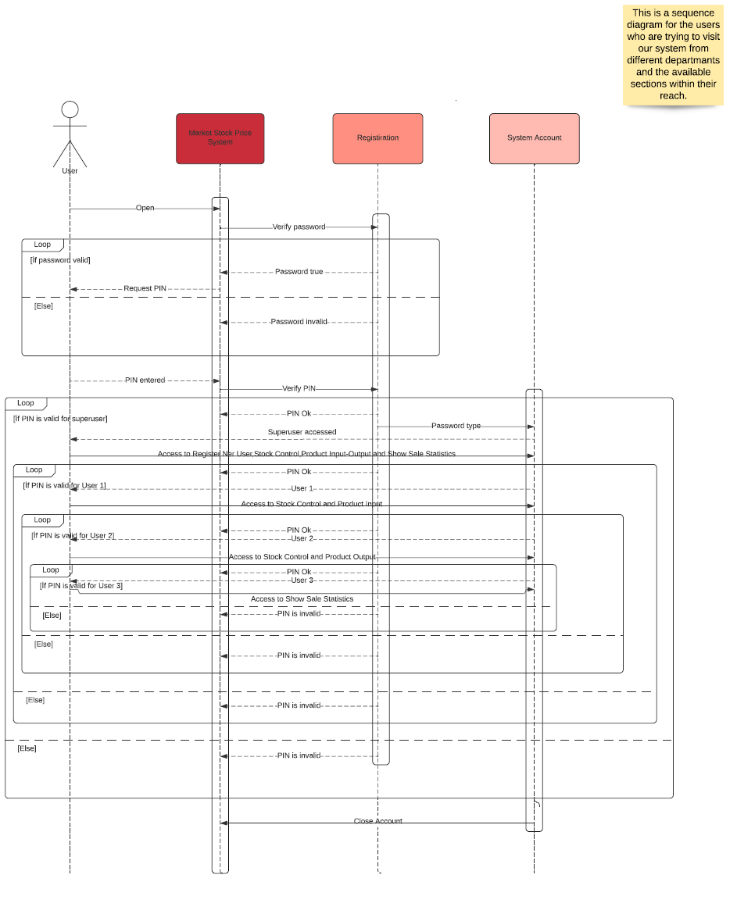
- Sequence Diagram 2
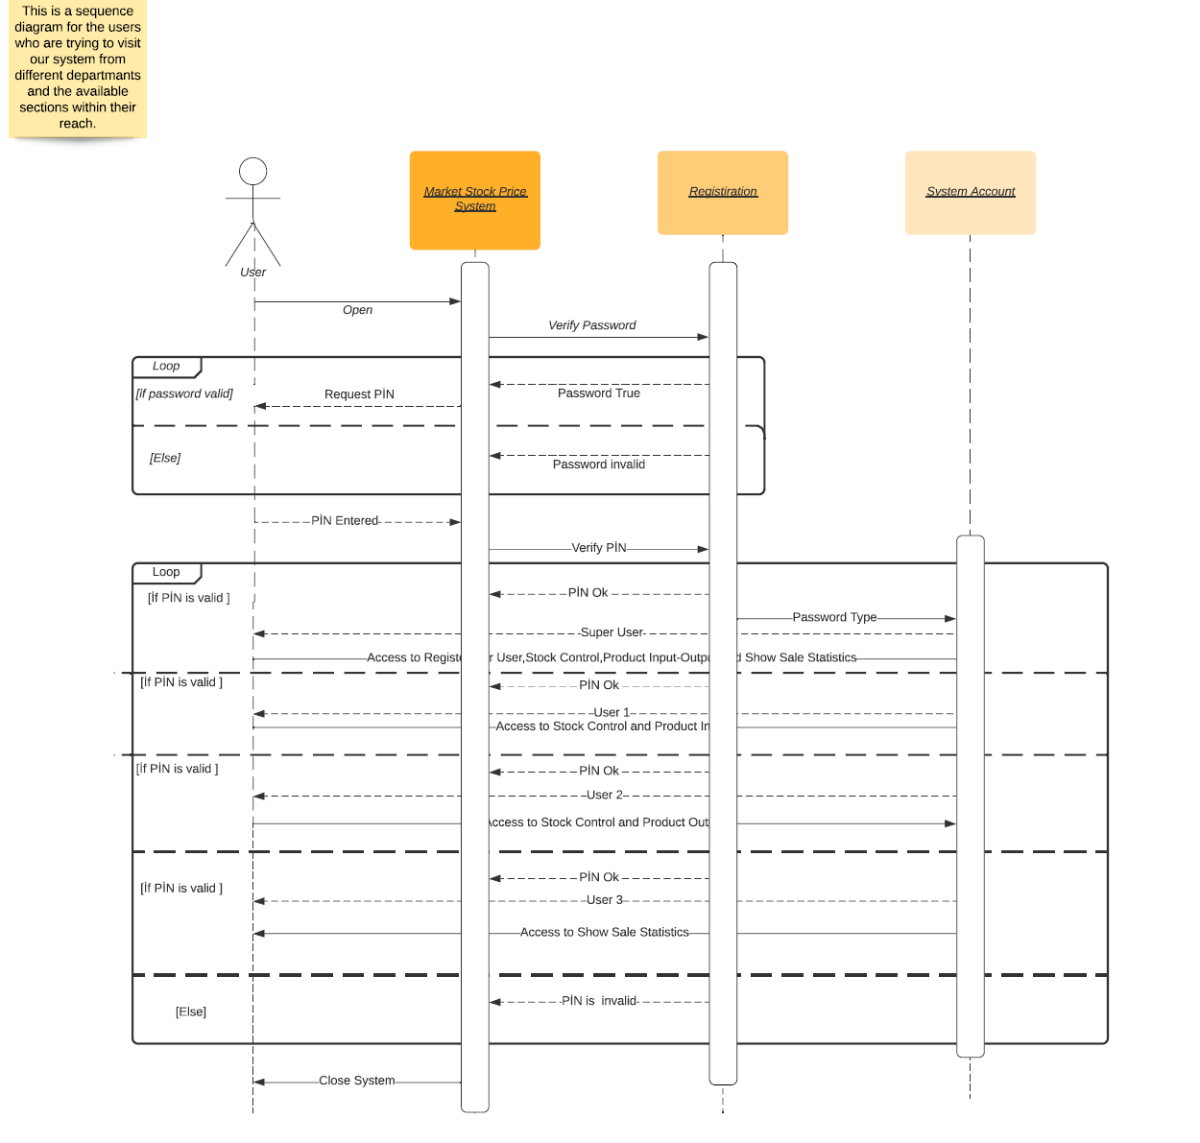

- Sequence Diagram 3
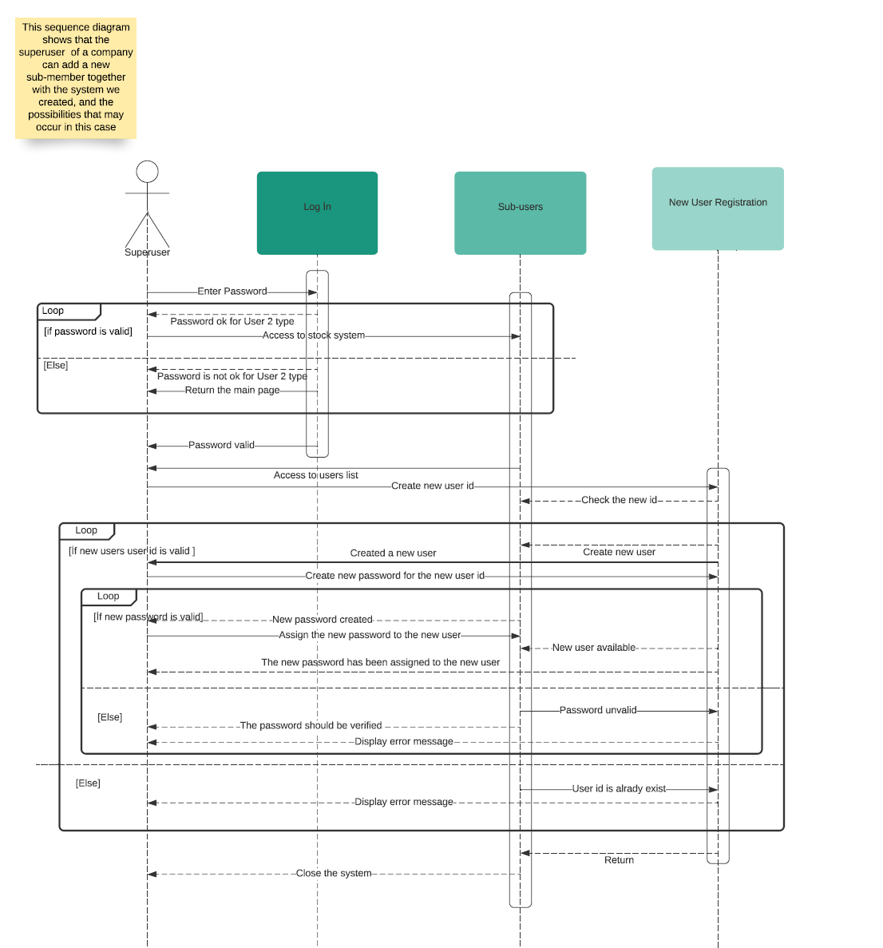

- Sequence Diagram 4
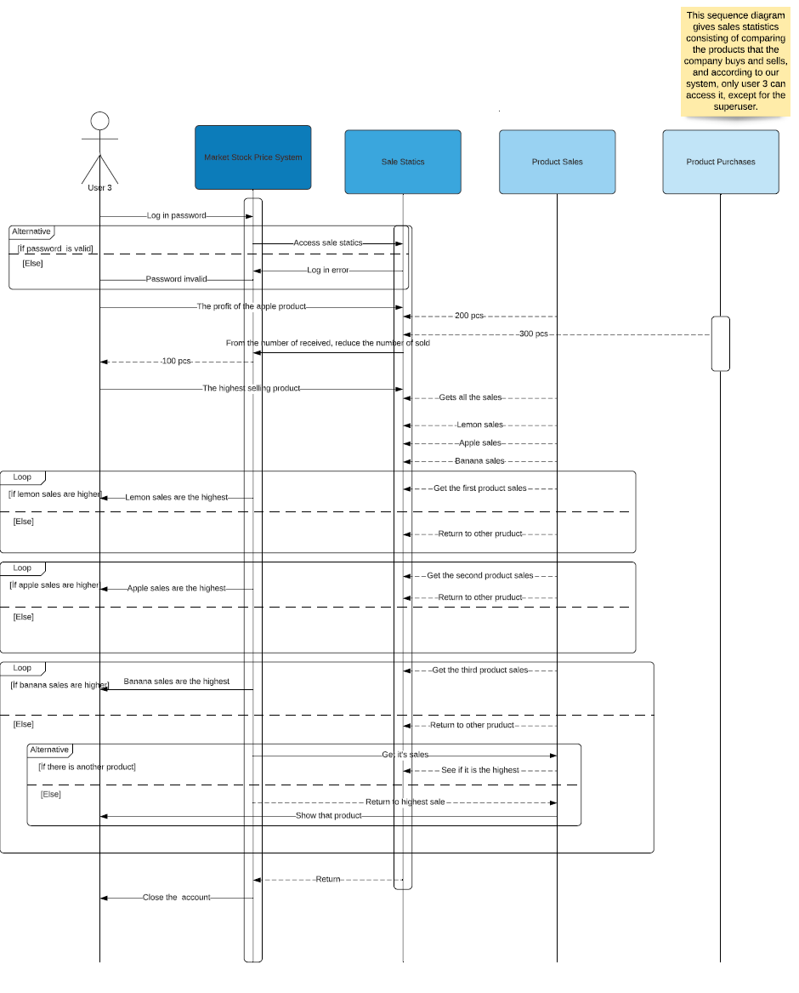
- Sequence Diagram 5

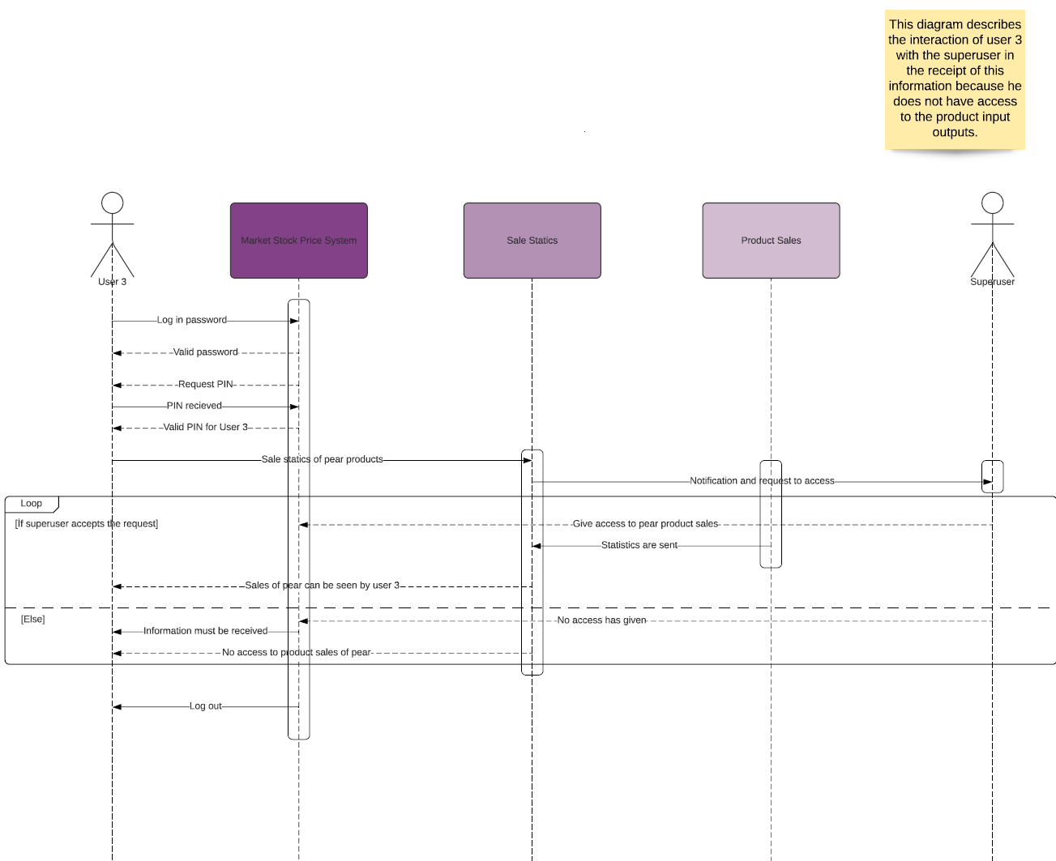

- Use Case Diagram
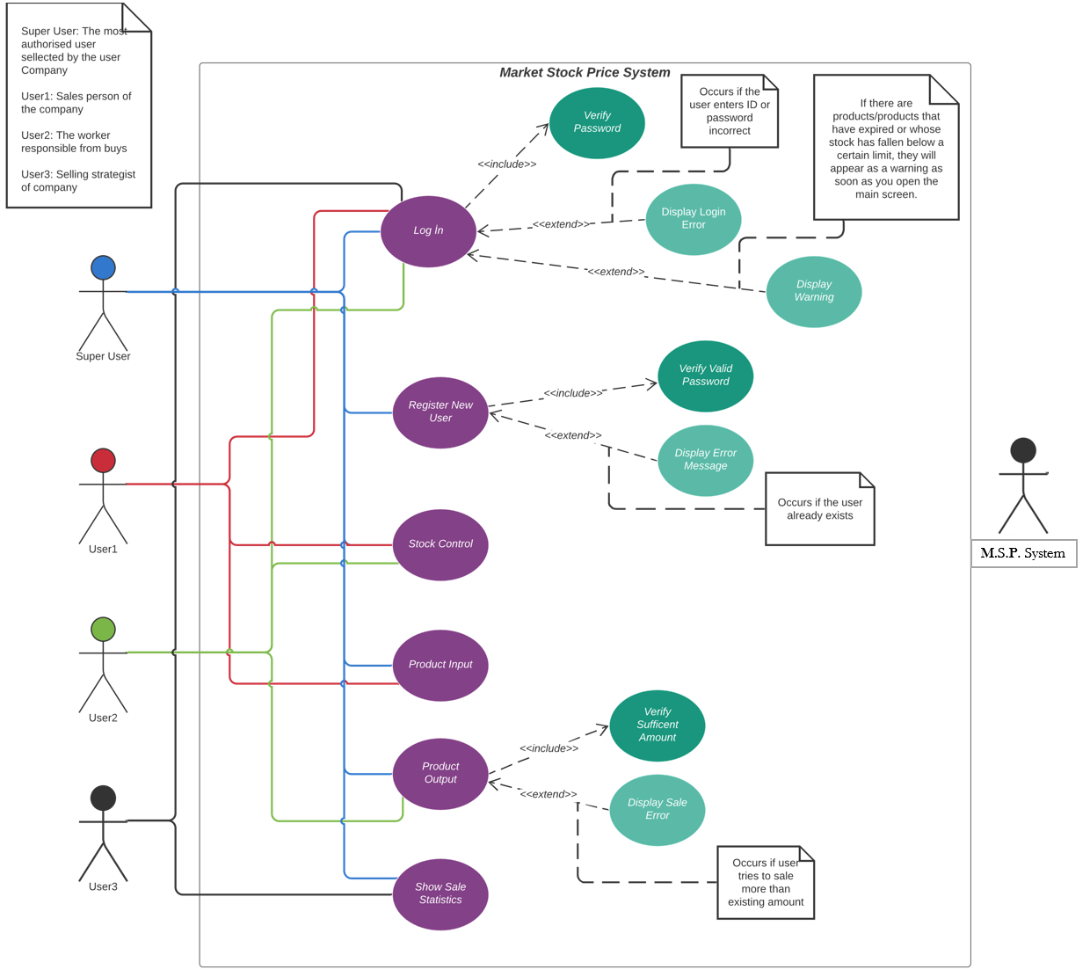

- Activity Diagram
